Contents
Introduction 2
Creating a Tab Delimited File Using the Excel File Template 3
Appendix A – Tab Delimited File Format 9
Appendix B – Upload Processing Rules 13

Version History
Version | Date | Notes
1.1 | 7/20/2018 | Took document for Learner Template B MOC submission to create this version which includes instructions to submit participants for TN licensing requirements.

Introduction

The tab delimited batch upload function in ACCME’s Program and Activity Reporting System (PARS) offers providers the ability to add or delete multiple participant records at one time. Although this function is available for use by all providers, it will be particularly useful to organizations that already have their own CME tracking system and have the ability to map the fields in their system to the fields in PARS.
Instructions for Using Learner Template B: These instructions provide detail for providers using “Learner Template B” to upload participant data for CME activities that are a part of the Licensing Data pilot or are registered for the American Board of Anesthesiology’s ABA MOCA 2.0 Program, the American Board of Internal Medicine’s MOC Program, the American Board of Pediatrics’ MOC Program, or the American Board of Pathology’s MOC Program. The main section of these instructions describes how to use a Microsoft (MS) Excel template to organize your participant data in such a way that it can be uploaded into PARS.
Appendix A − describes the data that are necessary for the upload.
Appendix B – Upload Processing Rules describes how to resolve error messaging that may occur on file upload.
Getting help with PARS: You can click on Help from any screen within PARS to access frequently asked questions and helpful videos. If you can’t find what you’re looking for in this information, you can submit your questions to the ACCME using the contact support interface within PARS. You may also contact the ACCME at info@accme.org or by phone with your questions.

Creating a Tab Delimited File Using the Excel File Template
It is important to note that it is not possible to upload data directly from an MS Excel file into PARS. The PARS MS Excel file template is offered as a tool to facilitate entry of data in a structured format. Once the data is in Excel, it is then easy to save it as a tab-delimited text file (.txt), which can be uploaded into PARS.
It is not necessary to use the MS Excel file template to create a tab-delimited text file. Other applications and data systems may offer the capability to export data directly into this format, although you may need some technical knowledge of the software that currently stores your data in order to set up this export. For detailed information about the fields required in the tab-delimited file, please refer to Appendix A.

How to Upload Participant Data Using the MS Excel File Template
- Download the appropriate MS Excel Participant upload template from {insert link to TN template} and save a copy to your computer.
- The MS Excel Participants upload template displays a header row followed by sample data rows. After reviewing the sample data, Clear Contents of the sample data rows. In Excel, you can Clear Contents by highlighting the rows, right clicking with the mouse, and then choosing Clear Contents.
Note: You may also delete these sample data rows, but deleting them will remove the validation on the cells. This validation provides helpful information during manual data entry.
If you plan to copy and paste data into the spreadsheet from other sources, or if you plan to use Excel formulas to add data to the spreadsheet, it is recommended that you delete the sample data rows instead of clearing them, to ensure that the format of the copied data is preserved.
- Copy one of the rows you cleared in Step Two, and paste it in the number of rows below that you will need for entering all the participants. This will copy the cell validation into the rows.
- Enter participant data into this file. All data on the same row must relate to the same activity, and one row is needed per participant with the following exceptions:
  - If a participant has earned credit from more than one licensing or specialty board, you must report each type of credit for that participant on a separate row.
  - If a learner completes an activity for which they earned different combinations of credit types in varying amounts, you need to submit a separate record for each combination of credits. For example, if a learner completes an ABA MOCA activity for which some, but not all credits count for patient safety, you need to report two records for that learner: one that includes the credits earned for ABA MOCA Part 2 with patient safety, and another record for the credits that are only applicable to ABA MOCA Part 2.
See the Appendix A - Tab Delimited File Format section of this document for specific data requirements. Additionally, please follow the below rule when using the Excel template to help ensure a successful upload:
- Do not change the order in which the columns appear.
Even if data is not required in a field, the system will expect the field to appear in the record with a blank (null) value, and the null value should be separated by tab-delimiters. If you use the Excel template file, leave the cells that do not contain data completely blank (do not enter a zero or a space—enter no character at all). The columns left empty will create the appropriate blank (or null) values automatically when you save the file as a tab-delimited .txt file.
- Save the file in the Excel format (.xls or .xlsx). This .xls or .xlsx version can be used if further changes are needed to the file. Below is an example of what your Excel file (with sample data) will look like after this step:
How to Create a Tab-Delimited Text File from the Excel File
- Choose the Save As option and save the Excel file as type Text (Tab delimited) (.txt).
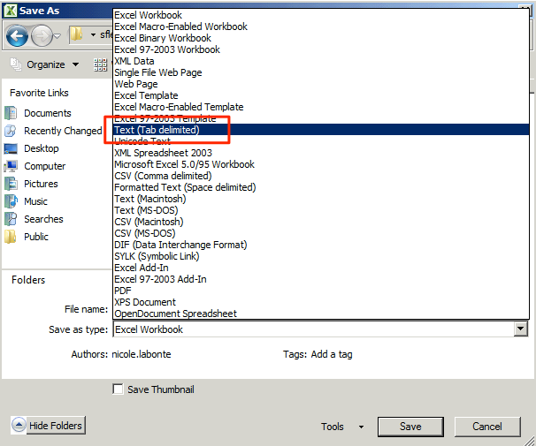
- After clicking Save, you may see a prompt in Excel that the selected file type does not support multiple sheets. Click the “OK” button to continue.
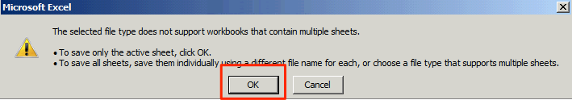
- If you are prompted that the file may contain features that are not compatible with tab-delimited text, click the “Yes” button to dismiss this message and save the file.

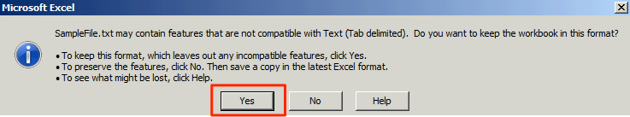
Note: The Excel file saved in Step 5 is only used for updating the file if changes are needed. The actual file that will be uploaded is the tab-delimited file saved within this step.
How to Upload the Tab-Delimited Text File
- Log into the ACCME Program and Activity Reporting System (PARS).
- Click the Activities tab
- In the left navigation in the “Activities” section, click the Batch Participant Upload link.
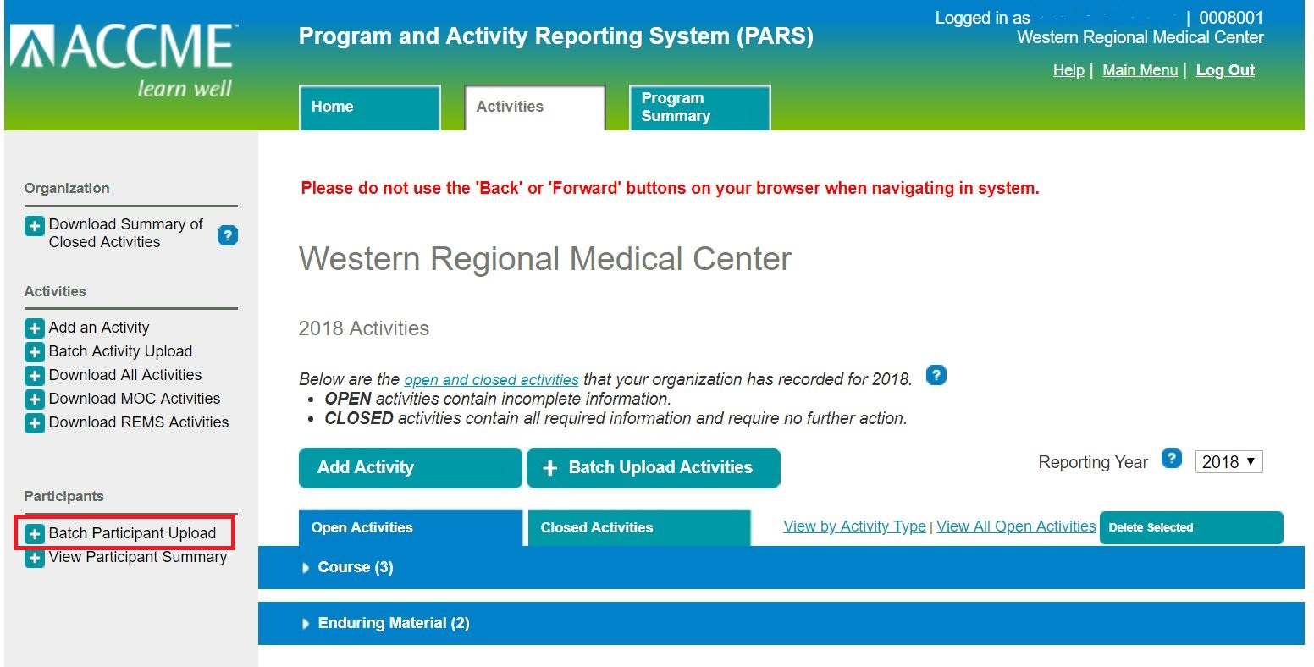
- On the Bulk Upload page, select the Tab Delimited option and select Next
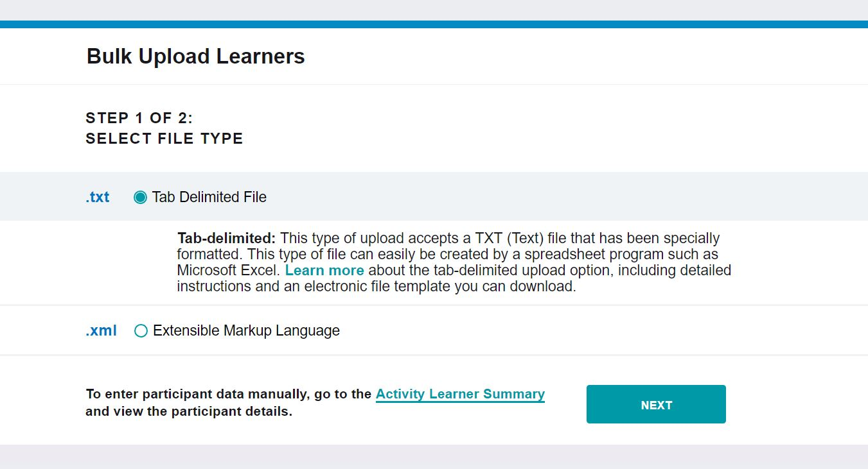
- Find the tab-delimited text file that you want to upload, and select the Upload File button.
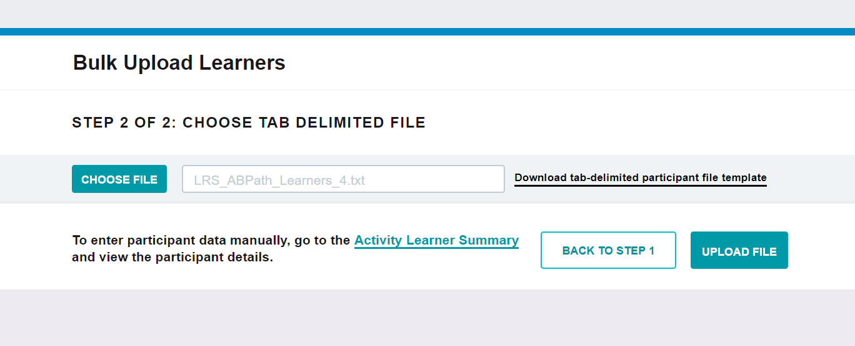
- The system will validate the file. If there are errors in the file, you will see a message on the screen that lists the problems and no participants will be uploaded to the system. To correct the errors, go back to the Excel file from Step 5 and fix the errors. Then complete subsequent steps to save a corrected tab-delimited (.txt) file for upload.
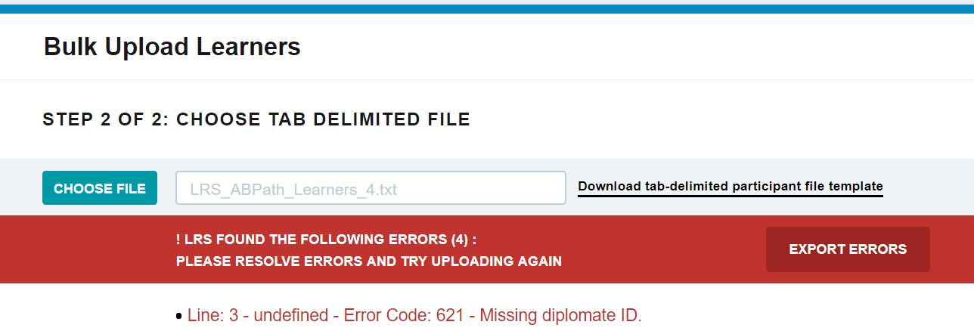
- If there are no errors in the file, a confirmation message will appear. 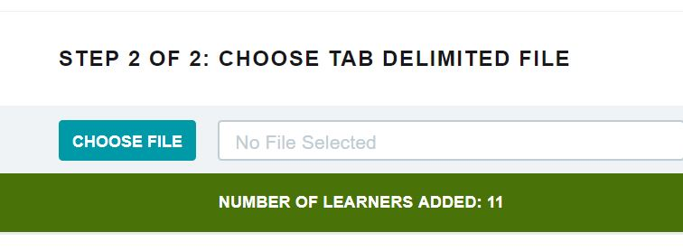

Appendix A – Tab Delimited File Format

- The tab-delimited text file must be saved and uploaded as a .txt file.
- There must be at least 12 fields present in each participant record. Even if data is not required in a field, the system will expect the field to appear in the record with a blank (null) value, and the null value should be separated by tab-delimiters. If you use the Excel template file, leave the cells that do not contain data completely blank (do not enter a zero or a space—enter no character at all). The columns left empty will create the appropriate blank (or null) values automatically when you save the file as a tab-delimited .txt file.
- When you prepare the Excel file that will be used to create a tab-delimited .txt file for upload to PARS, there are certain characters that should be avoided in the text entries. These characters, known as control codes, impart formatting to text within a cell and can include tabs within cells, carriage returns, and line feeds. When the Excel file is saved in tab-delimited .txt format, these characters will cause the columns and rows in your .txt file to break unexpectedly, and you will receive validation errors when you attempt to upload the file. Control characters should be removed from text in Excel before you create the .txt file for upload.
- The following table provides the details of the file format specifications:

List of Tab-Delimited File Format Fields

No | Field Name | Type/Format | Required Field? | Comments | Example Data
1 | Template | Text | Yes | The text “Learner Template B” must appear in this field. | Learner Template B
2 | Activity Registration | Text | Yes | Indicates the organization to whom the learner data should be sent. | TN, ABA, ABIM, ABP, or ABPATH
3 | ACCME Activity ID | Number (unique numeric ACCME Activity ID) | Yes | ACCME Activity ID is assigned by PARS, and can be found on the activity detail screen in PARS. | 100000000
4 | Learner ID Type | Text | Yes | Type of ID used to identify the learner | TN, NPI, ABA, ABIM, ABP, or ABPATH
5 | Learner ID | Number | Yes | The ID identified in the Learner ID Type field. Enter the specificed ID.  TN license numbers have no set number of digits  NPI will be 10 digits  ABA will be 8 digits with or without a dash.  ABIM will be a six digit number  ABP is defined as a number which today can be up to 7 digits, but continues to grow.  ABPath has no set number of digits. | 99999999
6 | Learner First Name | Text | Yes | The first name of the learner for whom participant data is being submitted. | Jane
7 | Learner Last Name | Text | Yes | The last name of the learner for whom participant data is being submitted. | Smith
8 | Learner DOB | Text date MM/DD | Yes for TN, ABIM, and ABPath | The month and day of birth of the learner, expressed as MM/DD. In Excel, this cell must be formatted as text, since MM/DD is not one of Excel’s standard date formatting options. | 01/23
9 | Date of Completion | Date in the format of MM/DD/YYYY | Yes | The date on which the participant completed the activity. This date must be equal or greater than the activity start date and must also be equal or before today’s date. | 03/30/2018
10 | Action | Text | Yes | If the participant data is being added, this field should have a value of “add”. If the record is being removed, this field should have a value of “delete.” | Add
11 | Number of Credits | Decimal (00.00) | Yes | Field for the number of credits the participant is claiming for this activity. | 5.25
12 | Activity Certification (1st) | Text | Yes | The type of credit that the learner is claiming for this activity.  Use “AMA PRA Category 1 Credit” to designate that CME credit was earned, and “TN Pain Management” to designate that the activity met the Tennessee board’s expectations surrounding opioid education. | AMA PRA Category 1 Credit, ABA MOCA Part 2,  ABIM MOC, ABIM MOC Part IV, ABP MOC Part 2, ABPath MOC Part II
13 | Provider Credit ID (1st) | Alphanumeric | No | Optional field for including any identifier generated by the CME provider that will be helpful to their process for data storage or tracking.
14 | Activity Certification (2nd) | Text | No | Optional field for including a second type of credit that the learner can claim. Leave this field empty if no ABIM or ABA MOC patient safety is being claimed. Use “ABIM MOC Part IV” to designate that points were earned for ABIM Practice Assessment MOC. | TN Pain Management, ABA MOCA Patient Safety, ABIM MOC Part IV, ABIM MOC Patient Safety, ABPath MOC SAM, ABPath MOC Part IV
15 | Provider Credit ID (2nd) | Alphanumeric | No | Optional field for including any identifier generated by the CME provider that will be helpful to their process for data storage or tracking.
16 | Activity Certification (3rd) | Text | No | Optional field for including a third type of credit that the learner can claim. | ABIM MOC Patient Safety, ABPath MOC Part IV
17 | Provider Credit ID (3rd) | Alphanumeric | No | Optional field for including any identifier generated by the CME provider that will be helpful to their process for data storage or tracking.

Appendix B – Upload Processing Rules
Is File Readable?
PARS will check that the file can be opened and read as a text (.txt) file.

If the file cannot be opened/read as a text file, you will see the following error message in the error report:
“File unreadable or file format not valid.”

If you attempt to upload an Excel file that has not been saved as a tab-delimited file, you will see the following error message:
“File extension of .XLSX detected. Please convert this file to a tab-delimited text file before uploading.”

Are Required Fields Included?
PARS will check that data is included in each of the required fields shown in the table in Appendix A. The following error messages may appear if required fields are not populated:

Error Message | Action Needed
Missing diplomate ID. | Each participant record must include a unique identifier used by the board.
Missing diplomate first name. | The diplomate’s first name must be provided in the Learner First Name field.
Missing diplomate last name. | The diplomate’s last name must be provided in the Learner Last Name field.
Missing diplomate date of birth. | The diplomate’s date of birth must be provided, and should be expressed as a two-digit month and two-digit day (MM/DD). Year is not required.
Missing ACCME activity ID. | The ACCME ID associated with the activity must be included with the participant record. The ACCME activity ID can be found in PARS.
Missing activity completion date. | Each participant record must include the date on which the participant completed the activity.
Learner record action was not specified. | An action of either “add” or “delete” must be included for each record, to indicate the action that should be taken.
Minimum number of required columns were not supplied. | This error typically indicates that the file was uploaded as a CSV file instead of a tab-delimited text file, and the contents of required fields cannot be read.

Are Fields in the Correct Format?
In addition to checking for missing fields, PARS will check that the data in each field is in the required format, specified in the table in Appendix A. The following error messages may appear if there are problems with the format of the data in any field:

Error Message | Action Needed
Learner record action is not valid. | An action other than “add” or “delete” appears in the Action field.
Activity completion date not valid. | The completion date must be expressed as MM/DD/YYYY.  This error may also appear if participant data is submitted for an activity with a date that occurs in the future.
MOC points awarded not valid. | This error may appear if the number of MOC points is a negative number.
Participant date of birth format not valid | The participant date of birth must appear as a two-digit month and two-digit month (MM/DD). If you continue to receive this error, check if Excel is converting the value in the Learner DOB field to a format such as “1-Jan.” Change the format of the field in Excel to a Text format and re-enter the date as MM/DD.

Does the Participant Record Follow Submission Rules?
When participant data is uploaded to PARS, some fields are validated immediately upon upload, to allow providers to correct errors in real time. The participant records are submitted to the specialty board at the end of each day. Additional validation occurs with specialty board processing and appears in PARS the following day.

The following error messages may appear in real time:

Error Message | Action Needed
Diplomate ID not found in Board records. | Verify the diplomate ID number is a valid ID number.
Mismatch of Board ID, Date of Birth, or Name. Please check fields. | The diplomate ID provided does not match date of birth (MM/DD) OR First and Last Name of the diplomate. Please check all fields to make sure they all match accordingly.
ACCME activity ID does not match with a registered MOC activity. | Participant data can be submitted only for activities that have been registered for MOC. To register an activity for MOC, locate the activity in PARS, chose the “update” option, and complete the “Maintenance of Certification” section on the activity detail. Participants can be added to an activity immediately after it is registered for MOC.
Activity completion date precedes activity start date. | Completion date for each participant record cannot occur before the date for the activity itself.

Correcting a File with Errors
If an error appears when I file is uploaded, none of the records in the file will be processed. Return to the original file and check that all required fields are included, and that the file has been saved as a tab-delimited text file. After saving any revisions to the file, upload it again, and repeat the process until all errors are resolved.

